Name of the event: Define Your Future (Prof. Samish Dalal).
Date: 26th September 2017.
Start Time: 12 pm.
End Time: 1:15 pm.
Aim.
The primary aim for conducting this event was to bring a globally acknowledged speaker and expert on a wide array of topics and the best speaker on the topic of “Family Business” and “Entrepreneurship”.
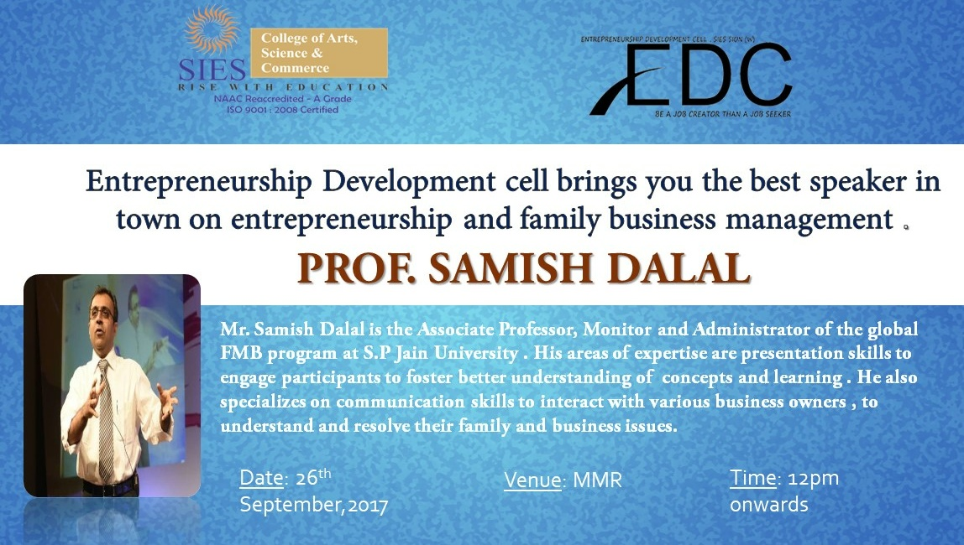
About the event.
The entire event was extremely well organized and executed by the entire Board of directors of the ‘Entrepreneurship Development Cell’ and attended by the more than 100 students including the EDC members and the BOD. It was also graced by the presence of our very own convener of EDC Prof. Anita Agrawal. Prof. Samish Dalal guided the students about the “how’s” and “why’s” of starting up a business enterprise. Through his own experiences and struggles he directed a path for the students to never be afraid of failure and face every challenge without looking back. His words truly inspired everyone in the audience and motivated a lot of them to create jobs instead of seeking one.
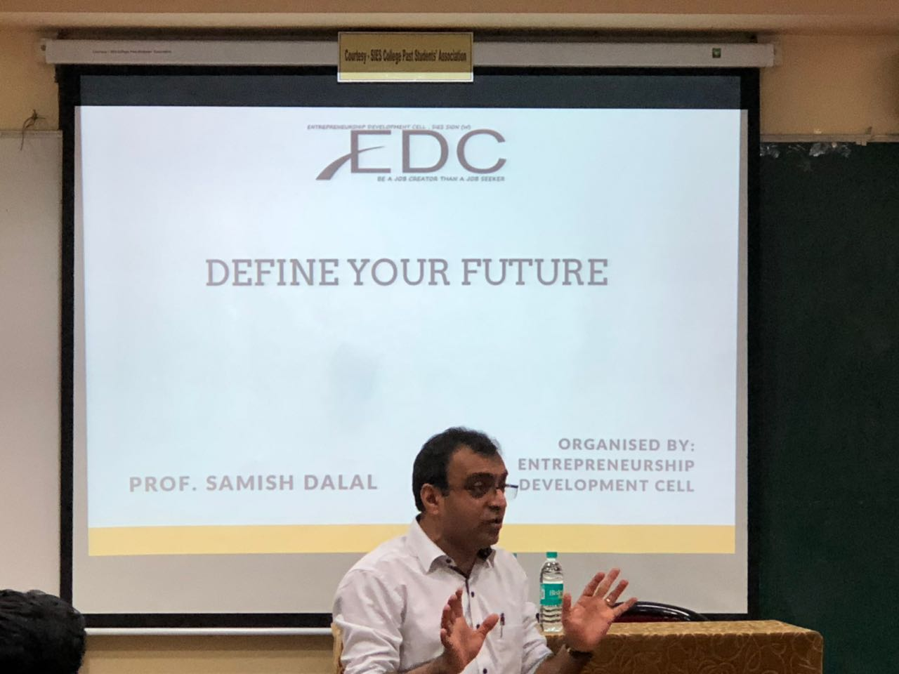
Summary.
By the end of the event every student in the audience was truly inspired by the words of Prof. Samish Dalal. His brilliant stage presence coupled with his immense knowledge about entrepreneurship and witty humor truly motivated the students.
